
NAME: BISMA FATIMA
CLASS: CS A
ROLL NO: F24605036
COURSE: INFORMATION SECURITY
COURSE CODE: CS-291
LECTURER: MISS ATTIA ASHRAF

OEL 01

OEL1 – Setting up a Virtual Environment in VMware Player
Tools Needed
∙ C compiler (e.g., gcc)
∙ OpenSSL library
Instructions
∙ Install OpenSSL development libraries if not already available:
sudo apt-get install libssl-dev
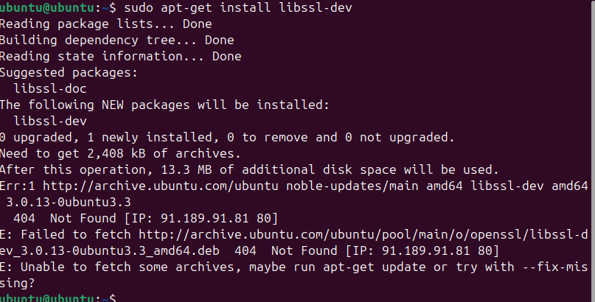
∙ Include the OpenSSL library in your C program.
#include <openssl/sha.h>
#include <openssl/evp.h>
#include <openssl/rand.h>
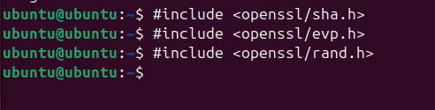
∙ Make sure to link the OpenSSL library when compiling your code:
gcc -o example example.c -lssl -lcrypto

∙ Use the following command to run your code:
./example
Task 1
Compile the given C program to use SHA1 function to compute hash of a message.
1. #include <stdio.h>
2. #include <openssl/sha.h>
3. #include <string.h>
4. int main() {
5. const char* message = "Hello, OpenSSL!";
6. unsigned char hash[SHA_DIGEST_LENGTH]; // SHA1 produces 160-bit hash (20 bytes)
7. // Compute SHA1 hash
8. SHA1((unsigned char*)message, strlen(message), hash);
9. // Print the original message
10. printf("Message: %s\n", message);
11. // Print the SHA1 hash in hexadecimal format
12. printf("SHA1 hash of the message: ");
13. for(int i = 0; i < SHA_DIGEST_LENGTH; i++) {
14. printf("%02x", hash[i]);
15. }
16. printf("\n");
17. return 0;
18. }
19.
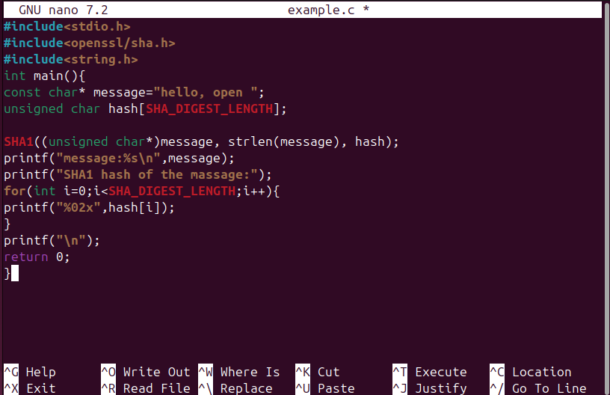
This prints the following output on your terminal:
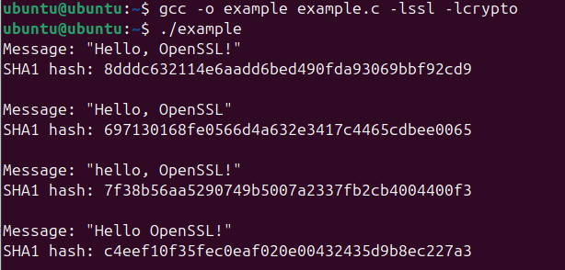Task 2
Compile this C program to use AES to encrypt and decrypt a message.
1. #include <openssl/evp.h>
2. #include <openssl/rand.h>
3. #include <stdio.h>
4. #include <string.h>
5. #include <stdlib.h>
6. #include <openssl/err.h>
7. #define AES_KEY_LENGTH 256 // 256-bit key for AES-256
8. #define AES_BLOCK_SIZE 16
9. void handleErrors() {
10. ERR_print_errors_fp(stderr);
11. abort();
12. }
13. // Encryption function
14. int encrypt(unsigned char *plaintext, int plaintext_len, unsigned char *key, unsigned char *iv, unsigned char *ciphertext) {
15. EVP_CIPHER_CTX *ctx;
16. int len;
17. int ciphertext_len;
18. if (!(ctx = EVP_CIPHER_CTX_new())) handleErrors();
19. if (1 != EVP_EncryptInit_ex(ctx, EVP_aes_256_cbc(), NULL, key, iv)) handleErrors();
20. if (1 != EVP_EncryptUpdate(ctx, ciphertext, &len, plaintext, plaintext_len)) handleErrors();
21. ciphertext_len = len;
22. if (1 != EVP_EncryptFinal_ex(ctx, ciphertext + len, &len)) handleErrors(); ciphertext_len += len;
23. EVP_CIPHER_CTX_free(ctx);
24. return ciphertext_len;
25. }
26. // Decryption function
27. int decrypt(unsigned char *ciphertext, int ciphertext_len, unsigned char *key, unsigned char *iv, unsigned char *plaintext) {
28. EVP_CIPHER_CTX *ctx;
29. int len;
30. int plaintext_len;
31. if (!(ctx = EVP_CIPHER_CTX_new())) handleErrors();
32. if (1 != EVP_DecryptInit_ex(ctx, EVP_aes_256_cbc(), NULL, key, iv)) handleErrors();
33. if (1 != EVP_DecryptUpdate(ctx, plaintext, &len, ciphertext, ciphertext_len)) handleErrors();
34. plaintext_len = len;
35. if (1 != EVP_DecryptFinal_ex(ctx, plaintext + len, &len)) handleErrors(); plaintext_len += len;
36. EVP_CIPHER_CTX_free(ctx);
37. return plaintext_len;
38. }
39. int main(void) {
40. unsigned char *plaintext = (unsigned char *)"This is a secret message."; unsigned char ciphertext[128];
41. unsigned char decryptedtext[128];
42. unsigned char key[AES_KEY_LENGTH / 8];
43. unsigned char iv[AES_BLOCK_SIZE];
44. int decryptedtext_len, ciphertext_len;
45. Page 3
46. if (!RAND_bytes(key, sizeof(key)) || !RAND_bytes(iv, sizeof(iv))) { fprintf(stderr, "Error generating random bytes.\n");
47. return 1;
48. }
49. ciphertext_len = encrypt(plaintext, strlen((char *)plaintext), key, iv, ciphertext);
50. printf("Message: %s\n", plaintext);
51. printf("Ciphertext: ");
52. for (int i = 0; i < ciphertext_len; i++) {
53. printf("%02x", ciphertext[i]);
54. }
55. printf("\n");
56. decryptedtext_len = decrypt(ciphertext, ciphertext_len, key, iv, decryptedtext); decryptedtext[decryptedtext_len] = '\0';
57. printf("Decrypted text: %s\n", decryptedtext);
58. return 0;
59. }
60.

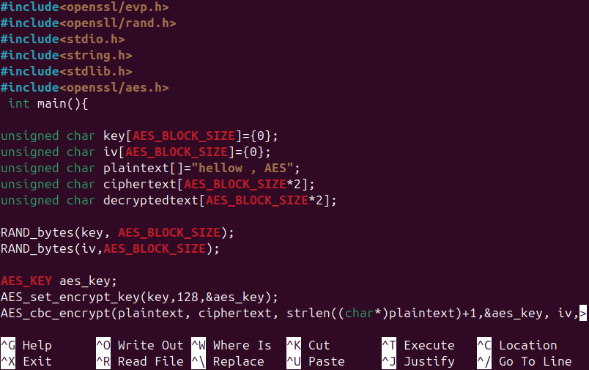
Questions
- In Task 1, you have computed hash for the message “Hello, OpenSSL!”. If you change the message slightly (e.g., remove exclamation mark ‘!’ or comma ‘,’ between words, change a capital letter to small letter, etc.), does the hash stay the same or does it change completely? Show your answer as an output on the terminal for three slightly different messages and state the reason.
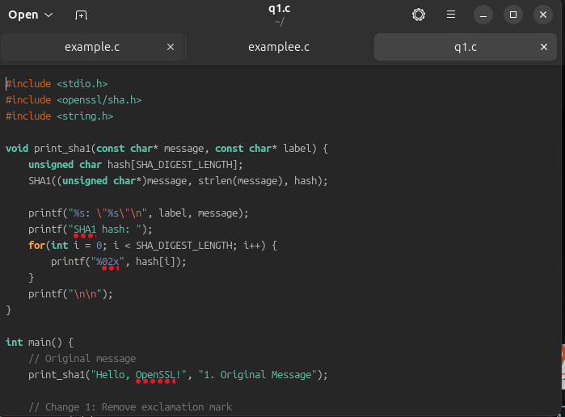
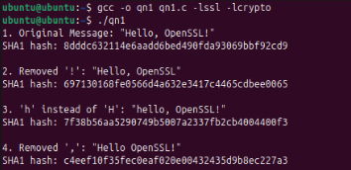
Explanation: Even a tiny change in the input (punctuation or case) results in a completely different hash. This is due to the avalanche effect in cryptographic hash functions, where a small change in input drastically changes the output.
- Does the length of the input message affect the length of the SHA-1 hash? Try computing the hash for different lengths of input (short and long messages) and compare the hash lengths.
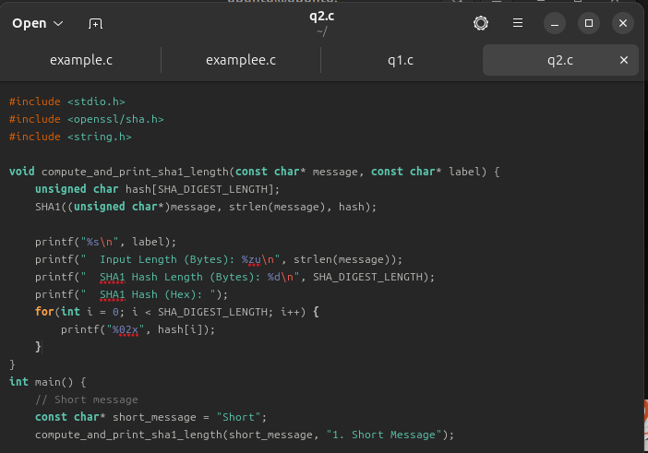
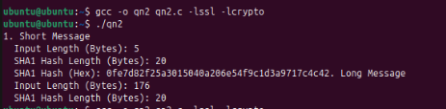

- Modify the code to experiment with different SHA functions (SHA-1, SHA-224, SHA-256, SHA-384, SHA 512).
- ∙ Update your program to allow switching between different SHA functions(SHA-1, SHA-224, SHA-256, SHA-384, and SHA-512).
- ∙ For each hash function, compute the hash of the same message and compare the output length and security level.
∙ Discuss the differences in hash length and security between the various SHA algorithms.
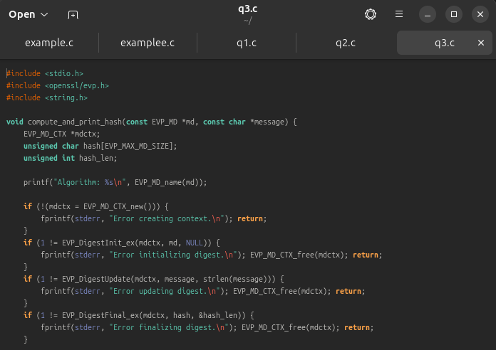
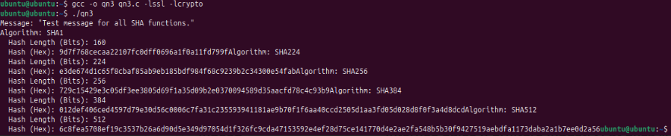
SHA Variant | Hash Length (bits) | Hex Length (chars) | Security Level
SHA-1 | 160 | 40 | Weak (deprecated)
SHA-224 | 224 | 56 | Moderate
SHA-256 | 256 | 64 | Strong
SHA-384 | 384 | 96 | Very Strong
SHA-512 | 512 | 128 | Very Strong

- Change one character in the original message and encrypt it again using AES. How different isthe ciphertext? Explain why this happens in AES encryption.

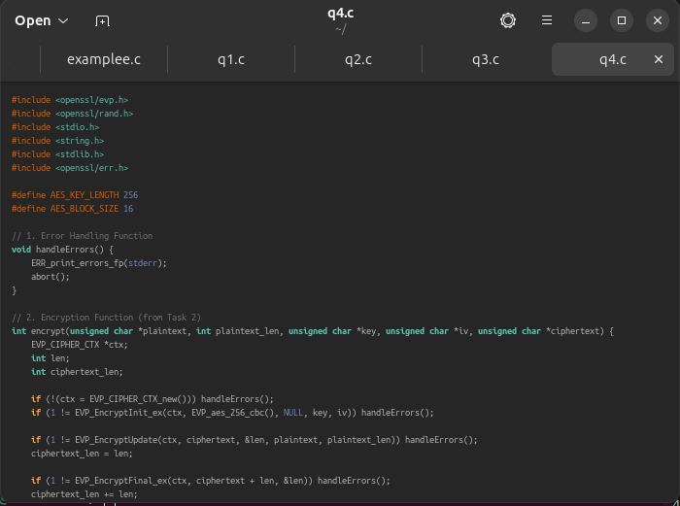
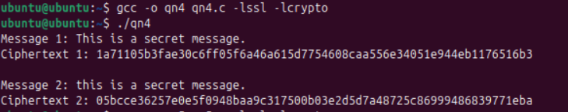
- Does chiphertext length change with a change in the length of plaintext when using AES encryption? Explain with the help of screenshots.

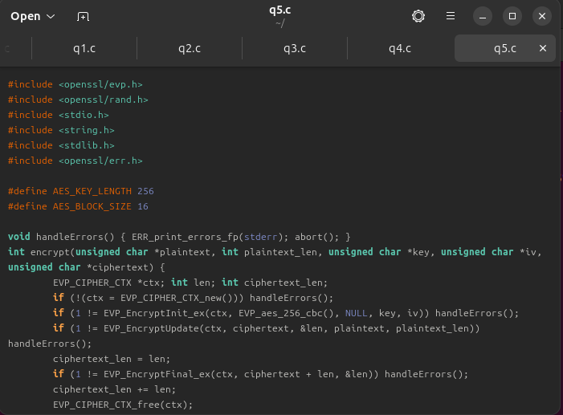
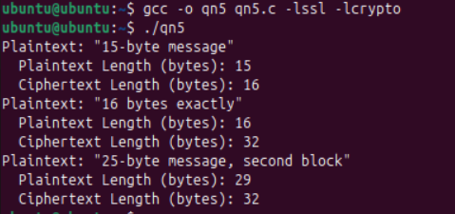

✅ Conclusion
- Hashing (SHA): Even tiny changes in input drastically alter the hash. Hash length is fixed per algorithm, regardless of input size.
- Encryption (AES): Small changes in plaintext yield vastly different ciphertexts due to block cipher behavior. Ciphertext length increases with plaintext length due to block alignment and padding.
- Security: SHA-256 and above are preferred for secure hashing. AES-256 is robust for encryption. Always use strong keys and secure configurations.

